## 1. SQL style

Terrific job! Now that we understand how SQL works, we'll review how it looks.

## 2. SQL formatting

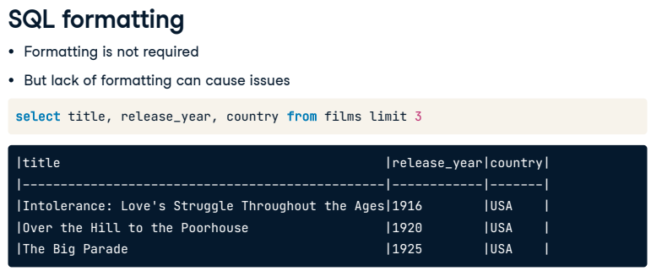

SQL is a generous language when it comes to formatting. New lines, capitalization, and indentation are not required in SQL as they sometimes are in other programming languages. For example, the code on this slide will run just fine, returning the first three titles, release years, and countries from the films table. However, writing queries like this won't make us any friends in the SQL world because the lack of formatting makes the code difficult to read, especially as queries become more complex.

## 3. Best practices

## 

Over time, SQL users have developed style standards that are generally accepted across industries. This code returns the same results as the code on the previous slide, but it is much easier to read due to the addition of capitalized keywords and new lines between them.

## 4. Style guides

## 

While keyword capitalization and new lines are standard practice, many of the finer details of SQL style are not. For instance, some SQL users prefer to create a new line and indent each selected field when a query selects multiple fields, as the query on this slide does.

## 5. Style guides

## 

Holywell's style guide: <https://www.sqlstyle.guide/>

Because of the different formatting styles, it's helpful to follow a SQL style guide, such as Holywell's, which outlines a standard of best practices for indentation, capitalization, and naming conventions for tables, fields, and aliases. Remember, though, that there is no single required formatting in SQL: the guiding principle is writing clear and readable code.

## 6. Semicolon

## 

Have you noticed the sample code we've been looking at throughout this lesson has a semicolon at the end? Like capitalization and new lines, this semicolon is unnecessary in PostgreSQL; we could leave it out of the query and still expect the same results with no errors. However, including a semicolon at the end of the query is considered best practice for several reasons. First, some SQL flavors require it, so it's a good habit to have. Including a semicolon in a PostgreSQL query means that the query is more easily translated to another flavor if necessary. Additionally, like a period at the end of a sentence, a semicolon at the end of a query indicates its end, which is helpful in a file containing several queries.

## 7. Dealing with non-standard field names

## 

One last note on SQL style: while we can ensure our code is formatted beautifully, we don't have control over other people's SQL style. When creating a table, a SQL mistake is including spaces in a field name. To query that table, we'll need to enclose the field name in double-quotes to indicate that, despite being two words, the name refers to just one field. For example, if a sloppy SQL coder had named a field release-space-year as two words, we'd need to update the query we've seen throughout this chapter to the one shown here.

## 8. Why do we format?

## 

Adhering to SQL style guides allows for easier collaboration between peers. Having clean and readable code is highly valued in the community and a professional setting and will make things easier for anyone wanting to understand or debug our queries.

## 9. Let's practice!

Let's try it out.

##### Exercise

#### SQL best practices

SQL style guides outline standard best practices for writing code.

This exercise will present several SQL style tips. Your job will be to decide whether they are considered best practices.

We'll be following [**Holywell's style guide.**](https://www.sqlstyle.guide/)

##### Instructions

* Drag and drop the items into the correct zone.

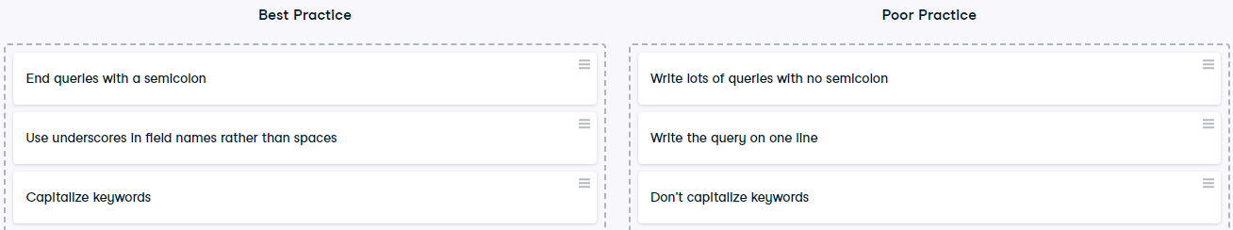

Well done! You'll soon become everyone's favorite SQL programmer.

## Exercise

# Formatting

Readable code is highly valued in the coding community and professional settings. Without proper formatting, code and results can be difficult to interpret. You'll often be working with other people that need to understand your code or be able to explain your results, so having a solid formatting habit is essential.

In this exercise, you'll correct poorly written code to better adhere to SQL style standards.

## Instructions

* Adjust the sample code so that it is in line with standard practices.



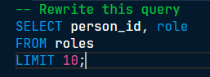

Great work formatting the code! Clean code allows for clean communication.

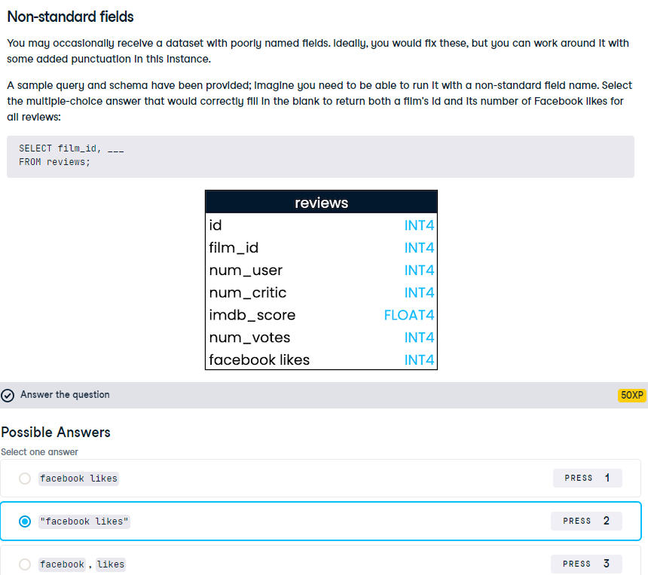

Correct! Using double quotes around a non-standard name allows us to run the SQL query.